**ZERO COPY CLONING**

As the name cloning suggests that it is copying database, schemas and tables (not temporary i.e. temporary tables cannot be cloned only permanent and transient tables can be cloned)

**Real time examples:**

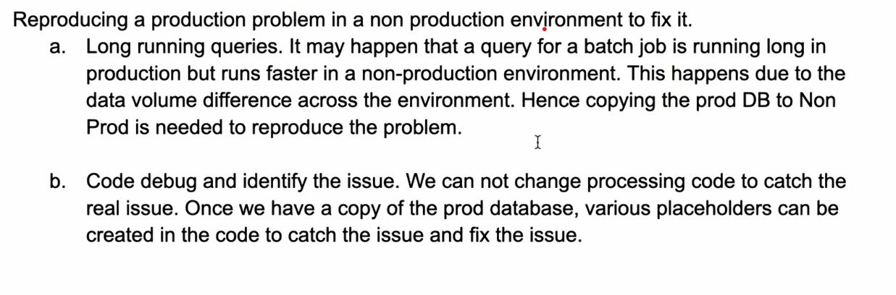

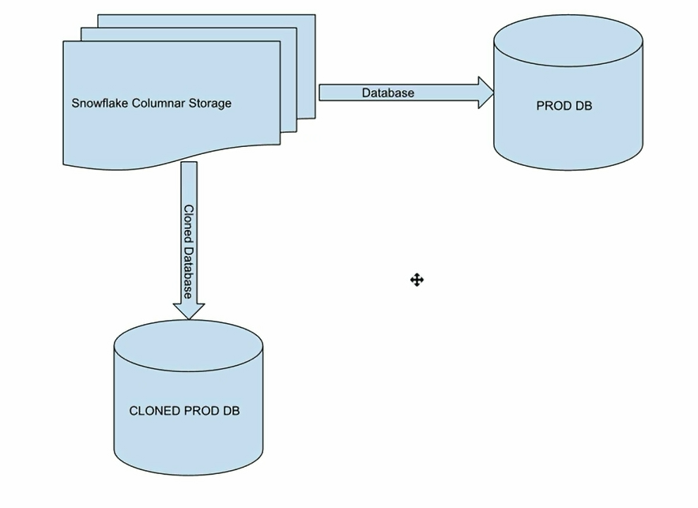

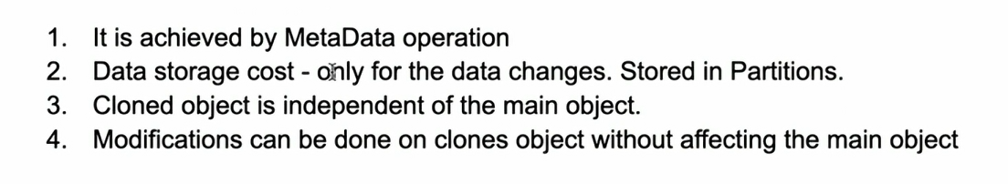

The Meta data of the cloned object is same as original object e.g. keys etc.

Objects that can be cloned other than database, schema and tables are

* Stages
* File formats
* Sequence
* Stream
* Tasks
* Foreign key constraints

What cannot be cloned are

* External tables
* Internal named stages

**Now, let’s do hands on cloning for permanent tables**

Create a table

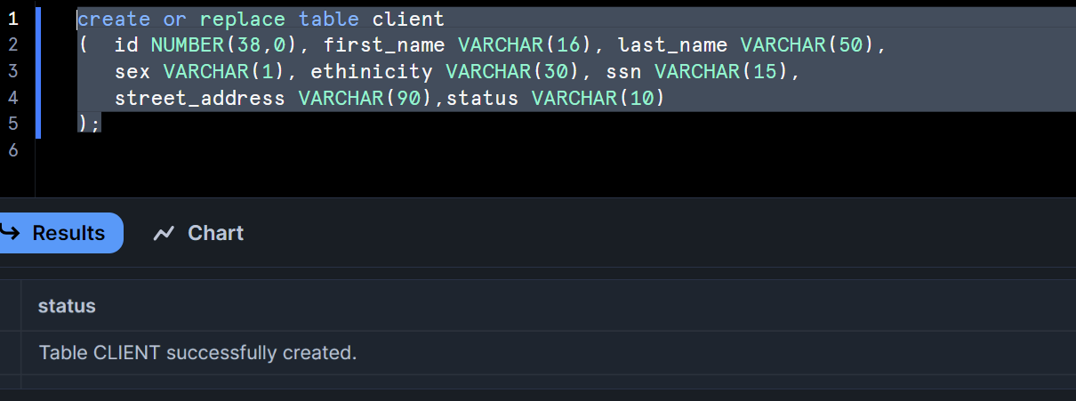

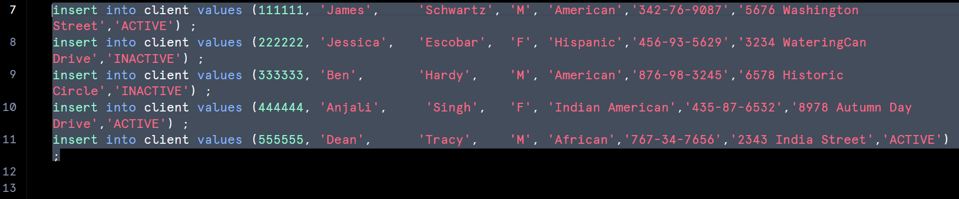

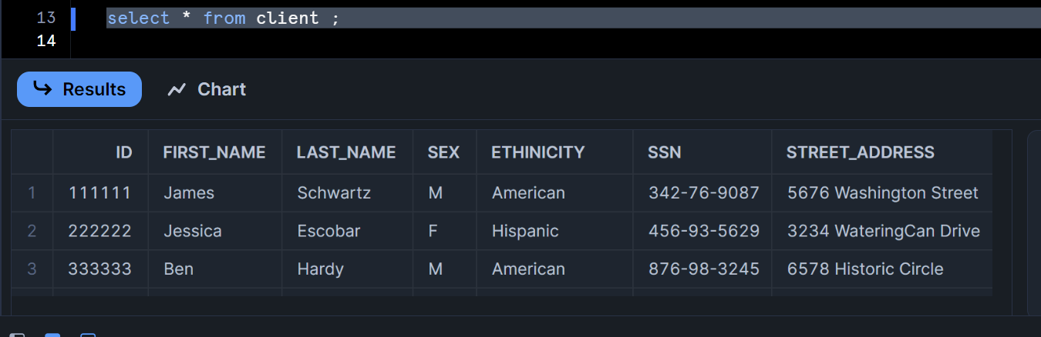

We have total 5 records in our client table

Let’s clone the table client

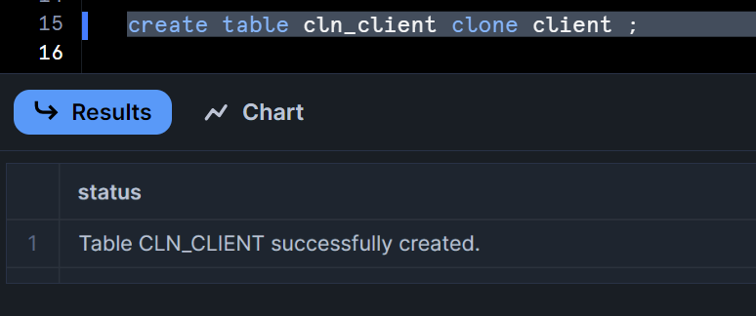

Let’s check our cloned table

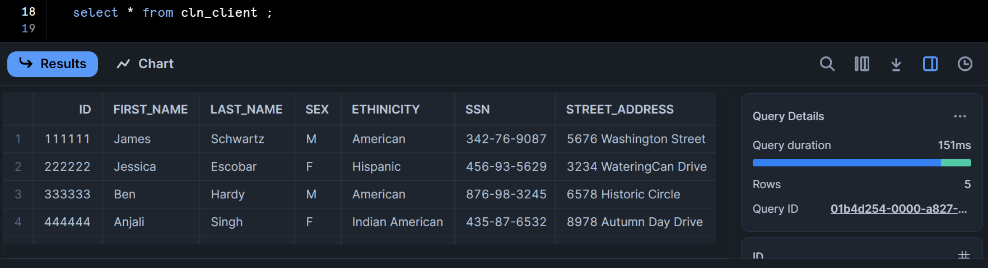

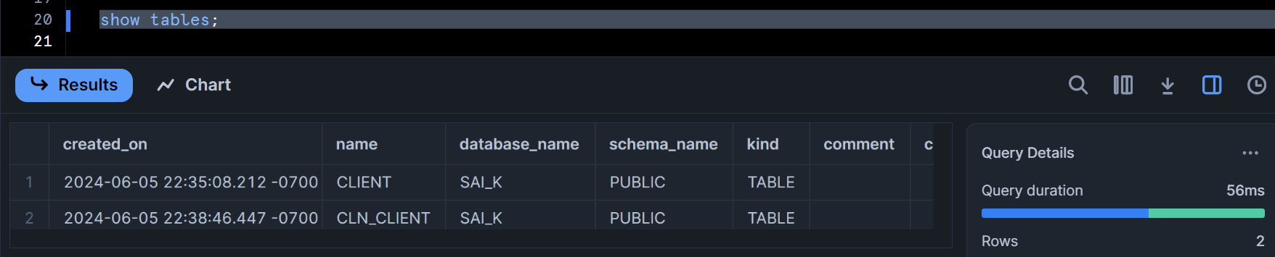

Let’s do some DML operations and validate that the original table is not impacted

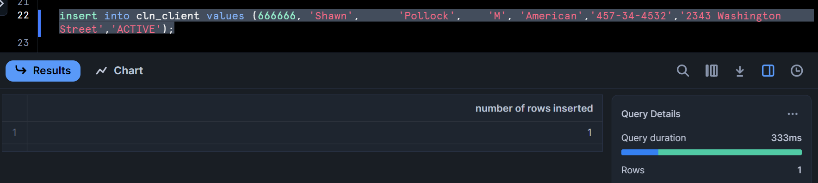

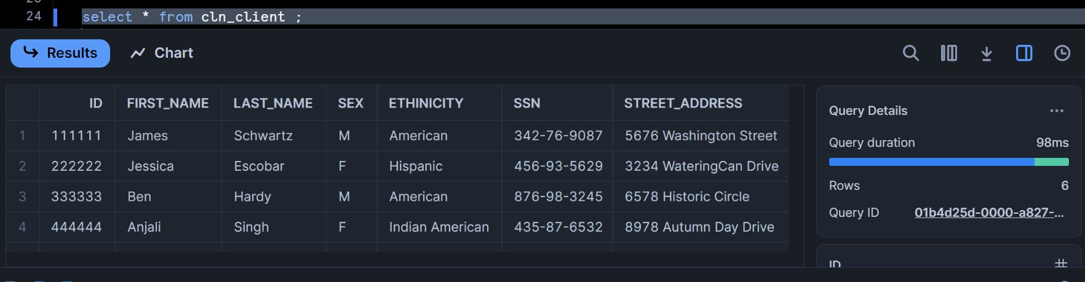

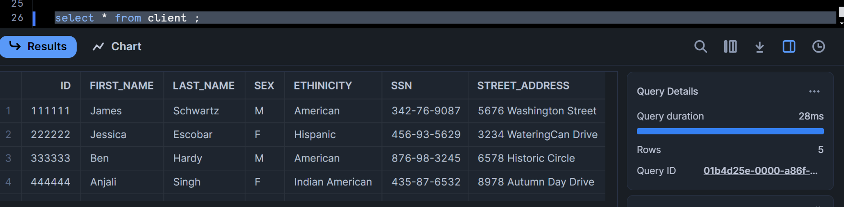

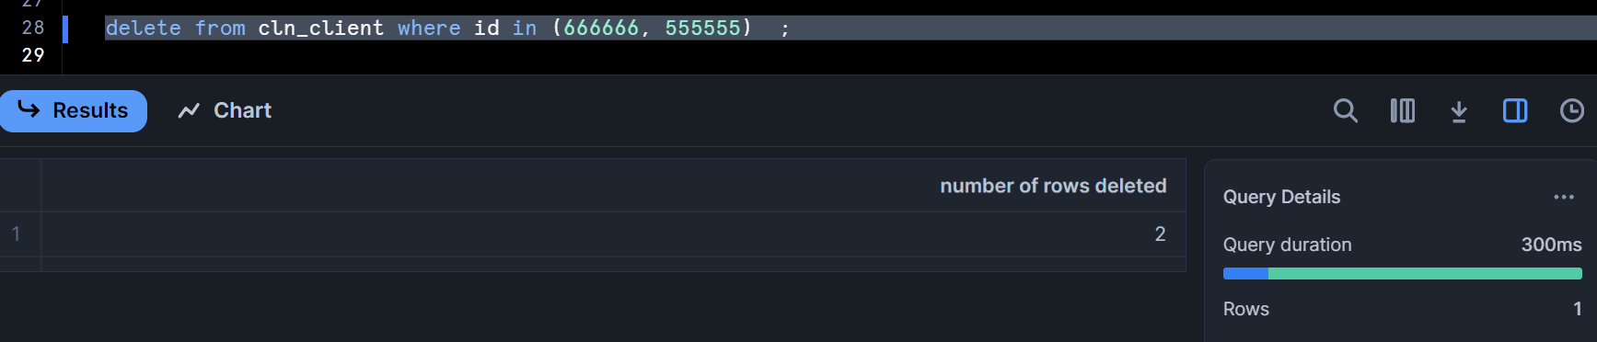

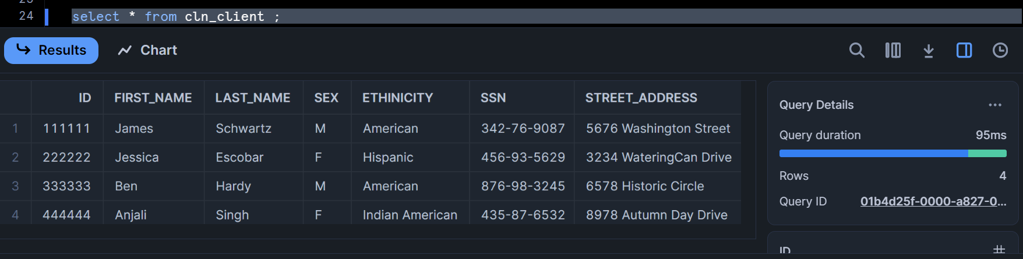

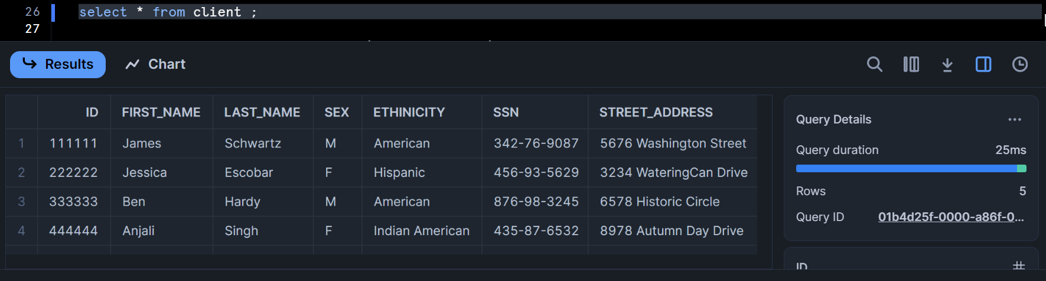

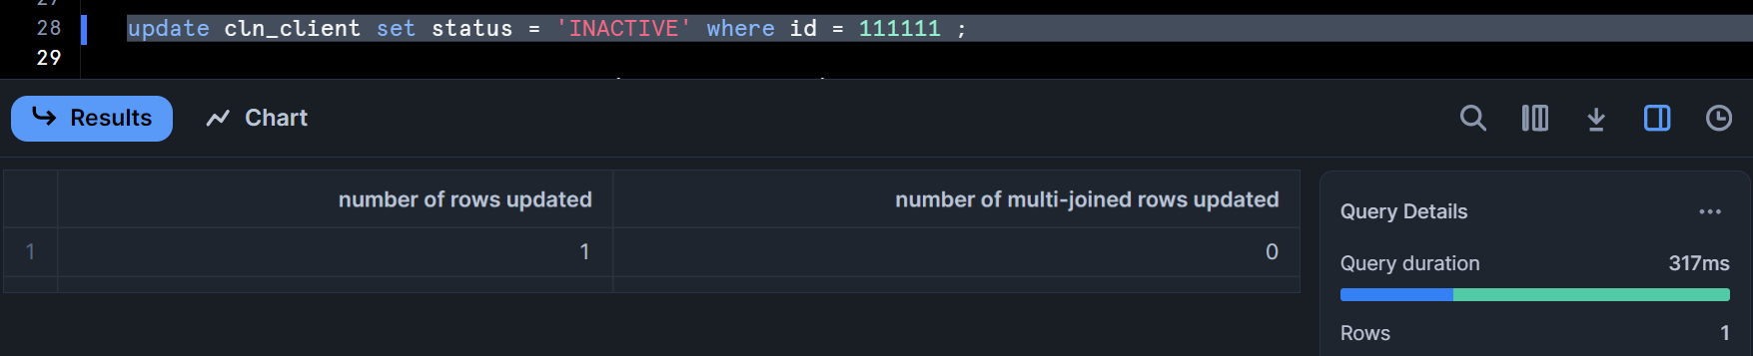

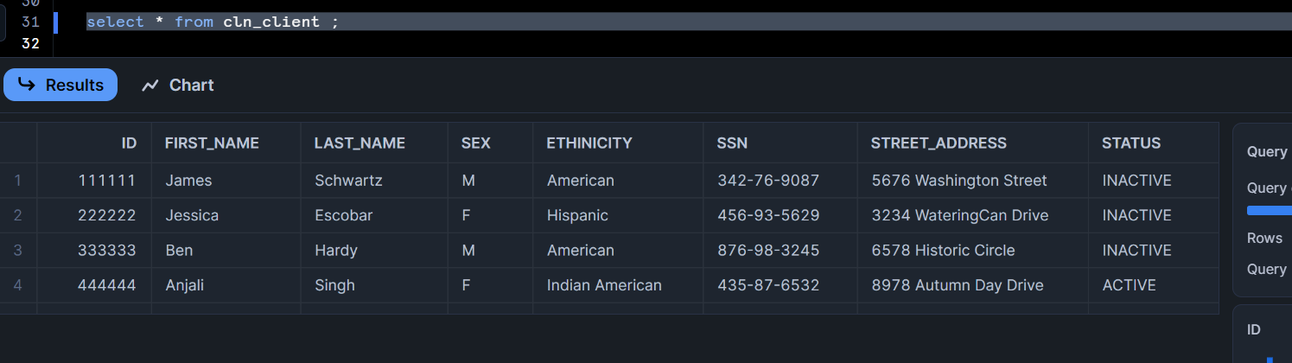

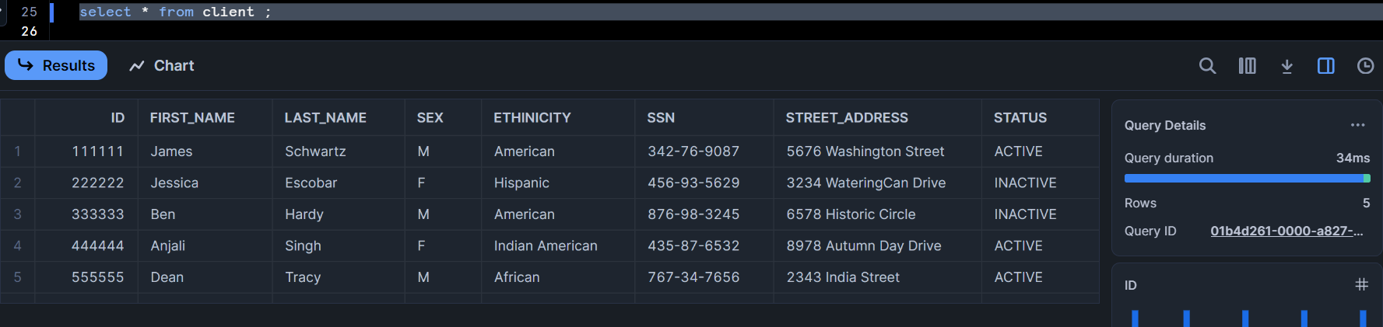

Hence, main table will be unaffected if do DML operations on your cloned tables

Note:

* For large table cloning which takes some time to run
* Do not execute DML until cloning is done

**To avoid costs sometimes the data retention is kept at 0**

* If data is deleted from source table while cloning is in progress, the cloned object might not have the data
* How can this be avoided, set retention as 1, then clone once clinging is done reset back to 0
* You can keep the retention as 0 for cloned tables to avoid costs

**We learned in previous session how to set retention at table level**

**Copy grants and more on cloning**

Let’s compare the effect of cloned table on main table with & without grants

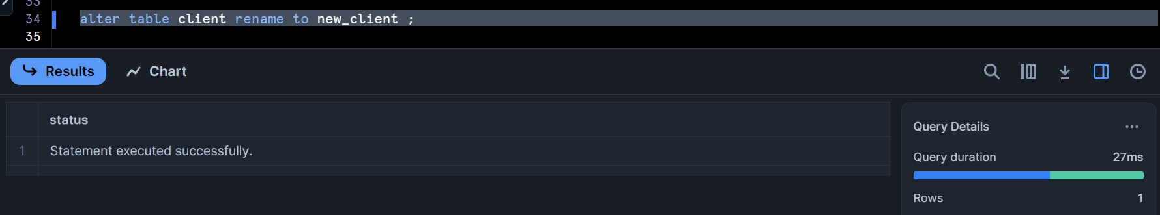

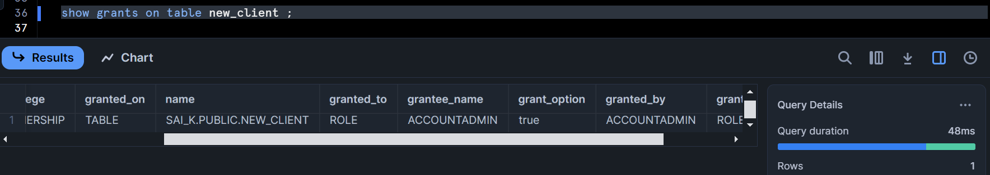

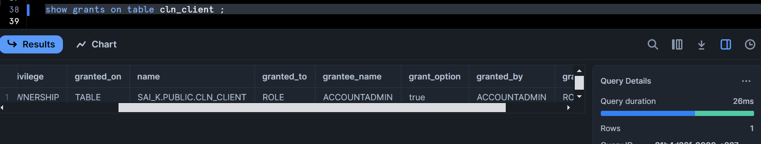

Give grant to sysadmin for new_client and check

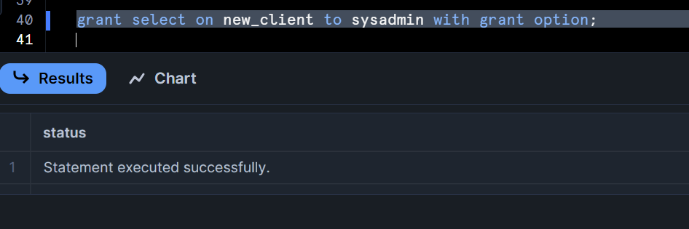

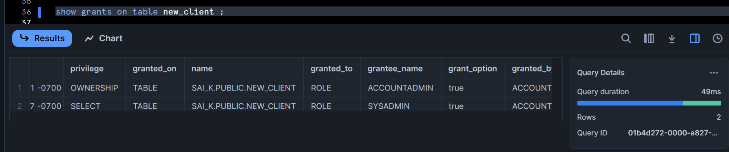

Let’s clone without grants

Cloning main table into cln_client_wog table

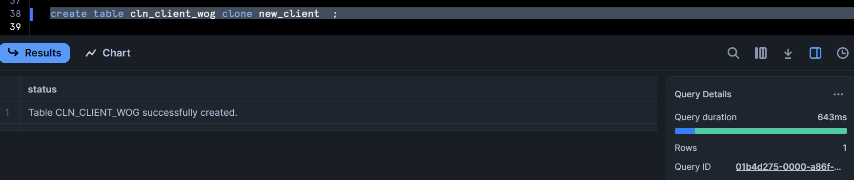

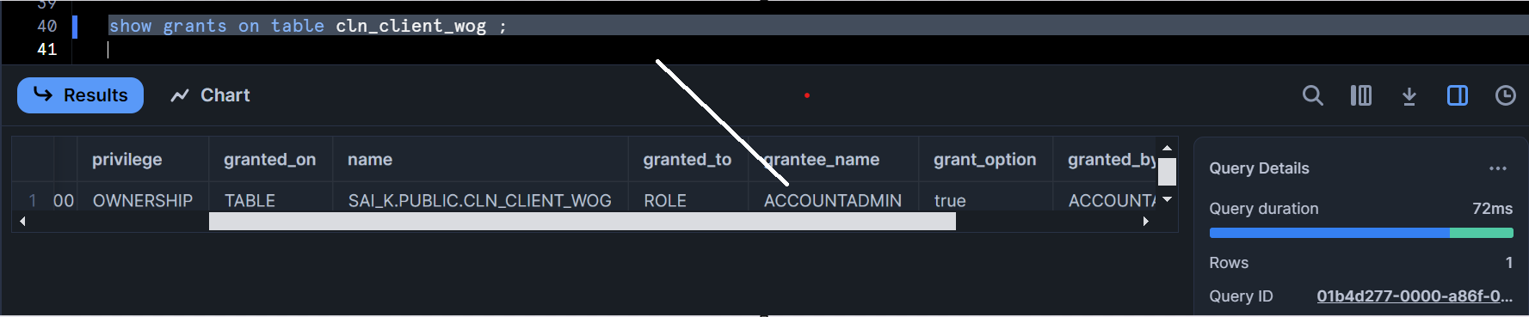

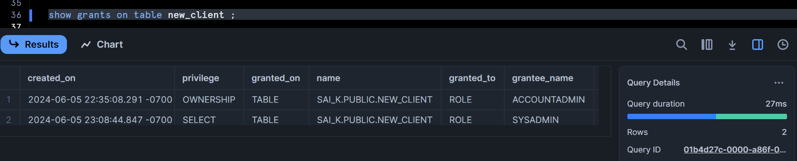

**Clone with grants**

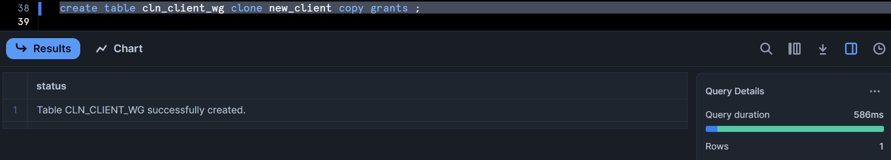

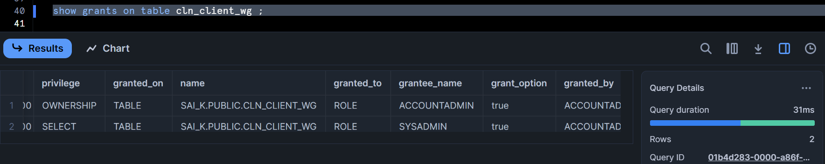

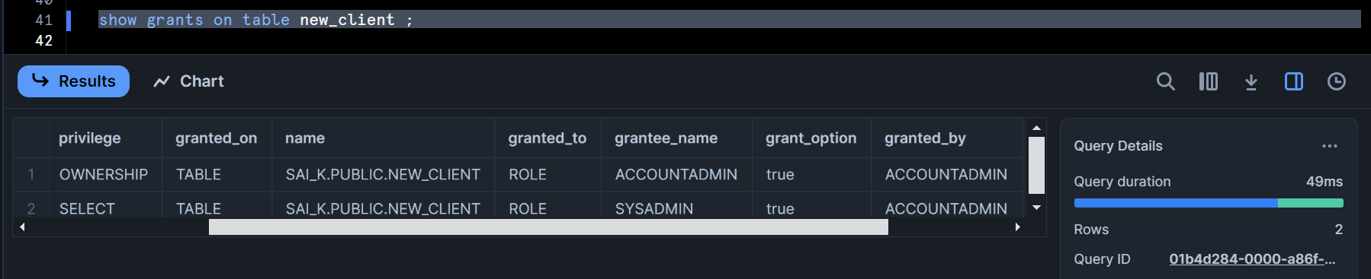

Let’s check on temporary & external tables i.e. cannot clone temporary and external tables

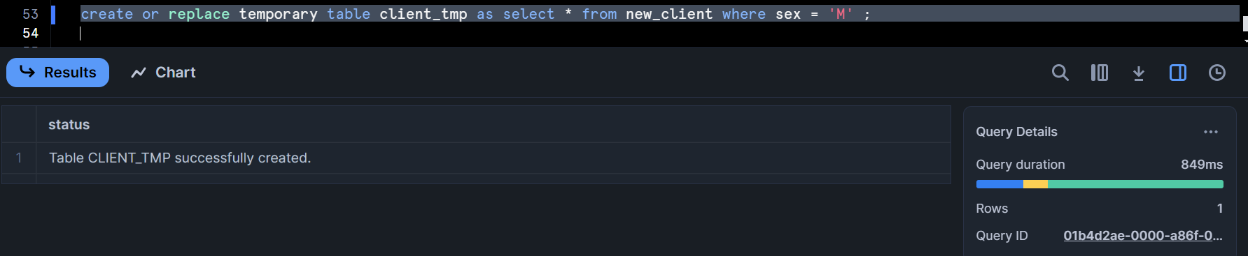

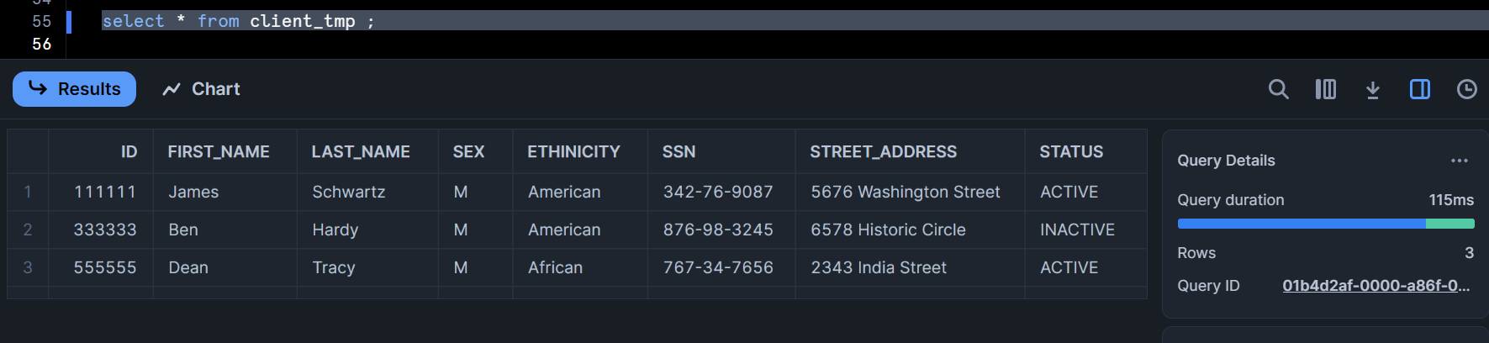

Create a clone of temporary table - does not work (This command tries to create a permanent table)

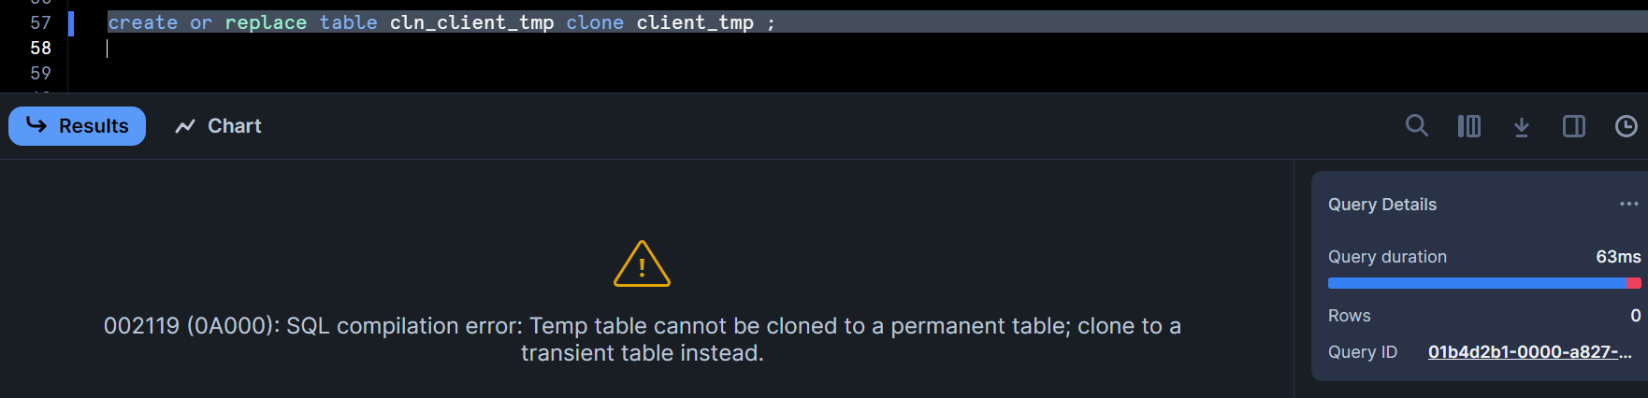

Let’s clone with transient table and temporary table

Transient clone of temp table is possible

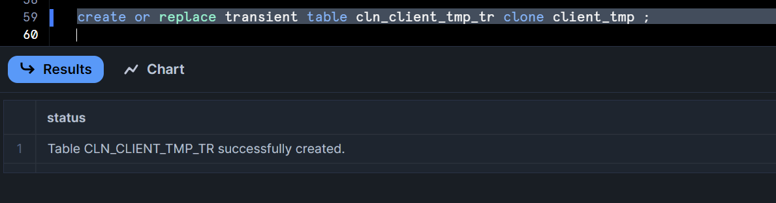

Temporary clone of temporary table is possible

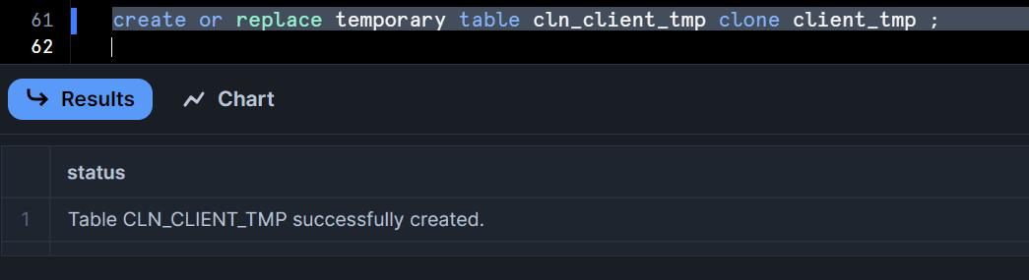

**External table clone not allowed:**

**Note:** as to show you in practical as it takes lot of pages, will explain you step by step

Create a storage integration object and give your URL’s in storage locations

Create file format

Create external stage for loading data

Create external table

Check the data of external table

Create clone on external table - Does not work, here is the syntax

**Create table cln_promotions_ext clone promotions_ext;**

**Cloning schema and database:**

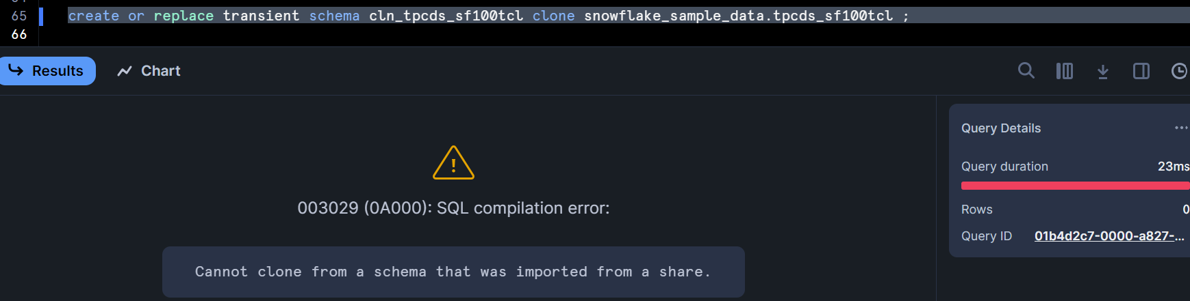

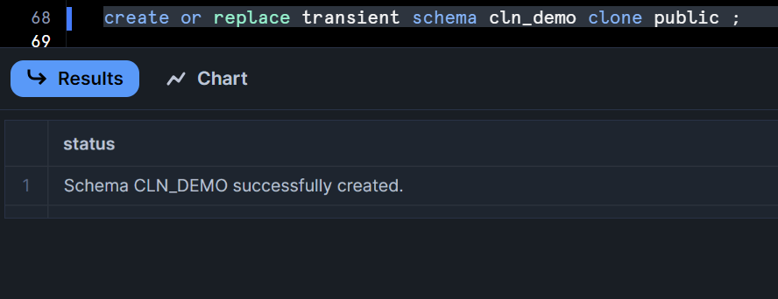

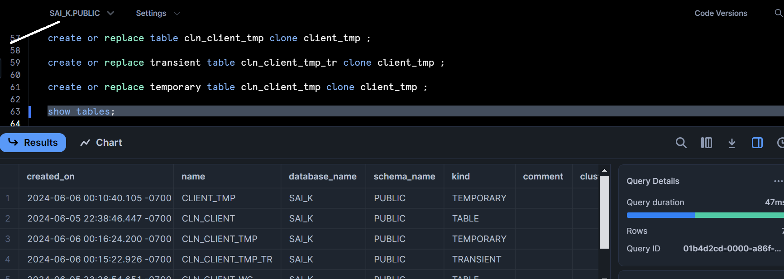

**Use schema cln_demo and check**

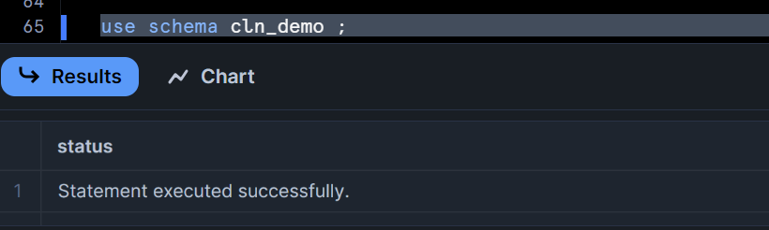

**You don’t see external tables**

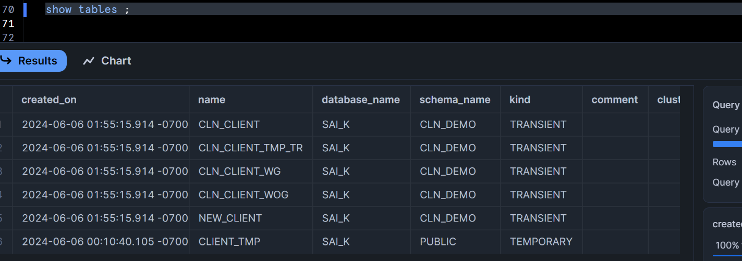

**Let’s do the same for database**

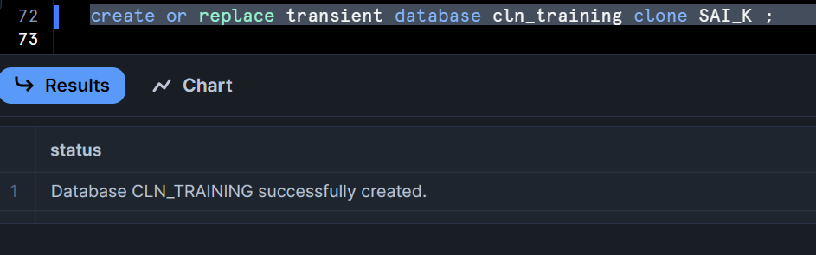

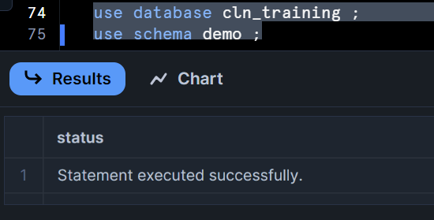

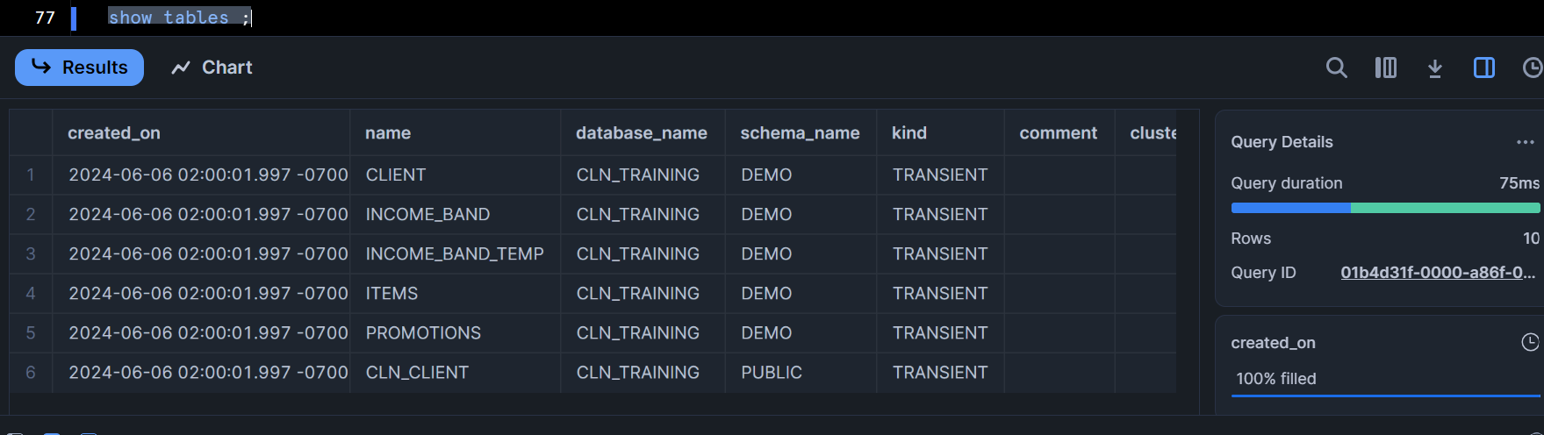

Similar case as that of schemas where no external tables will be present as it doesn’t support external tables

Schema across database can be created by giving the <database>.<schema> qualifiers

I.e. clone of a clone

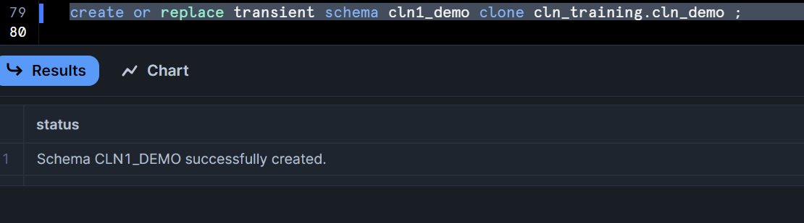

Clean up:

Drop database cln_training;

Drop schema cln1_demo;

Drop schema cln_demo;

**Swap:**

Let’s do practical

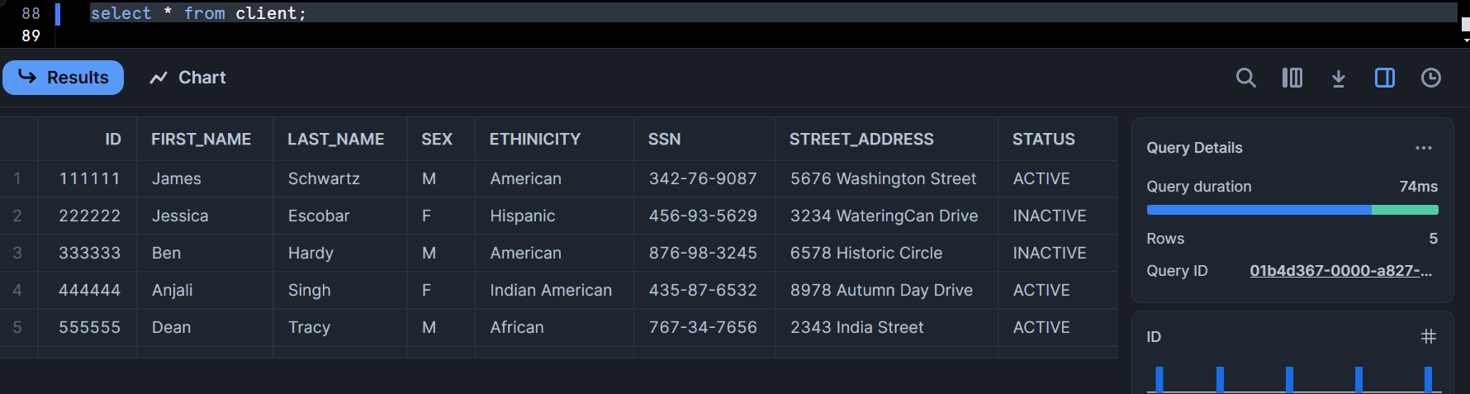

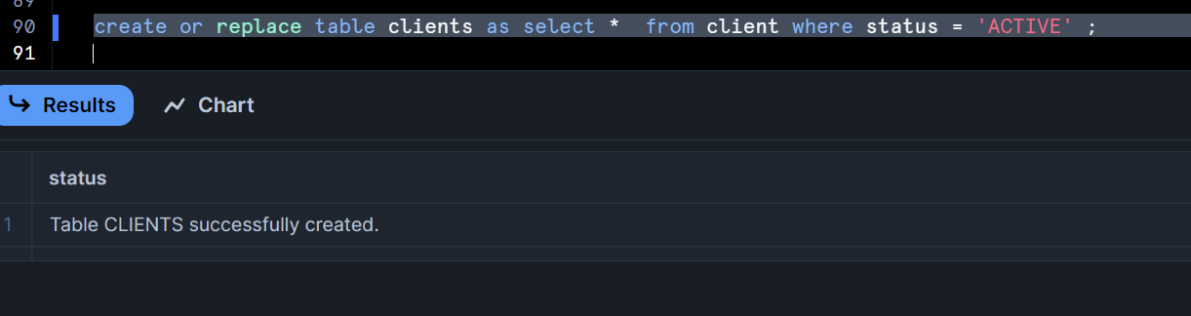

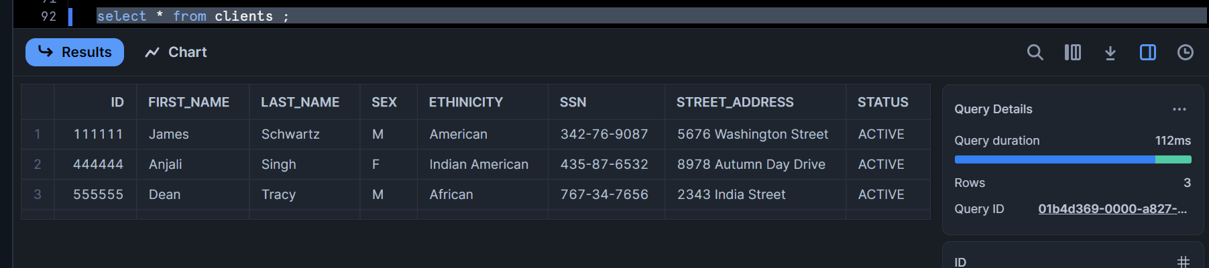

Client has 5 rows and clients has 3 rows

We can swap both

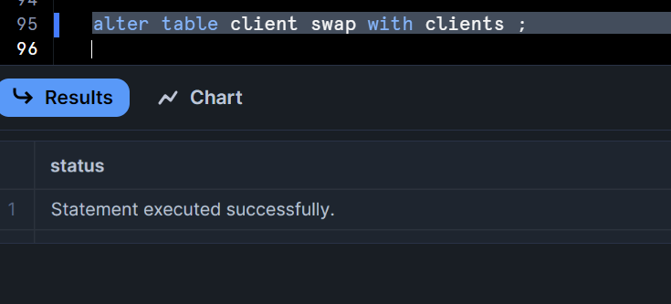

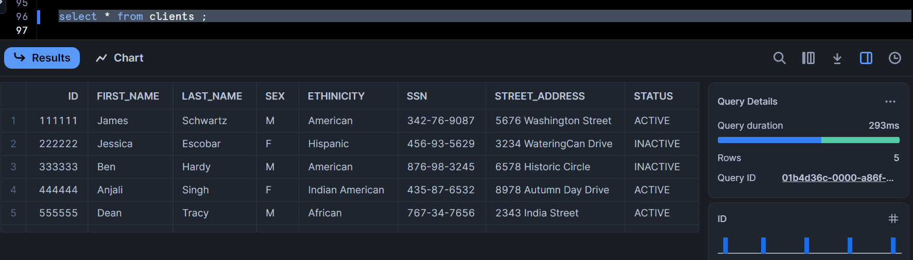

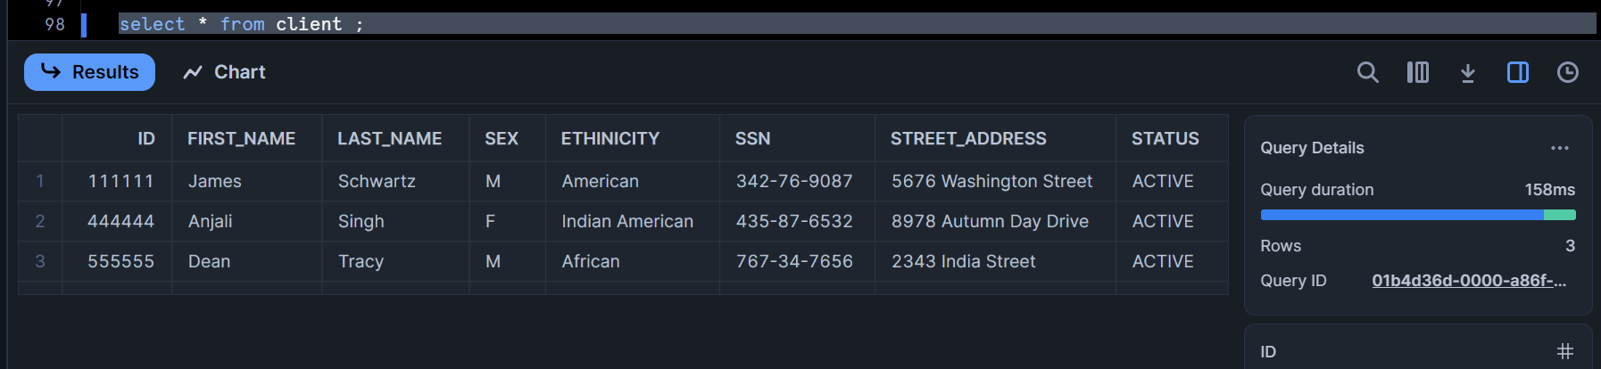

Similarly the same with both schemas and databases, you can swap

**Clone using Time Travel**

Delete and copy query ID

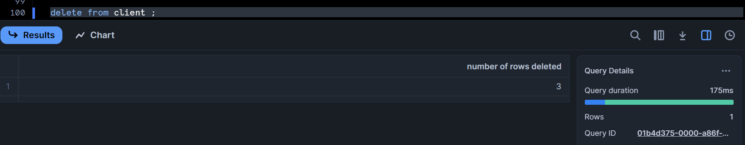

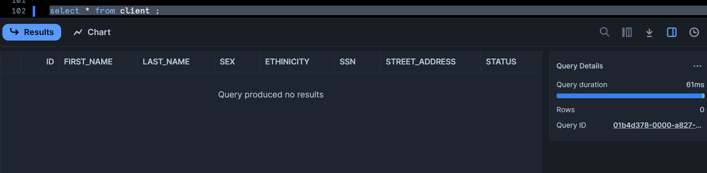

Create clone using before statement, copy your Query ID here

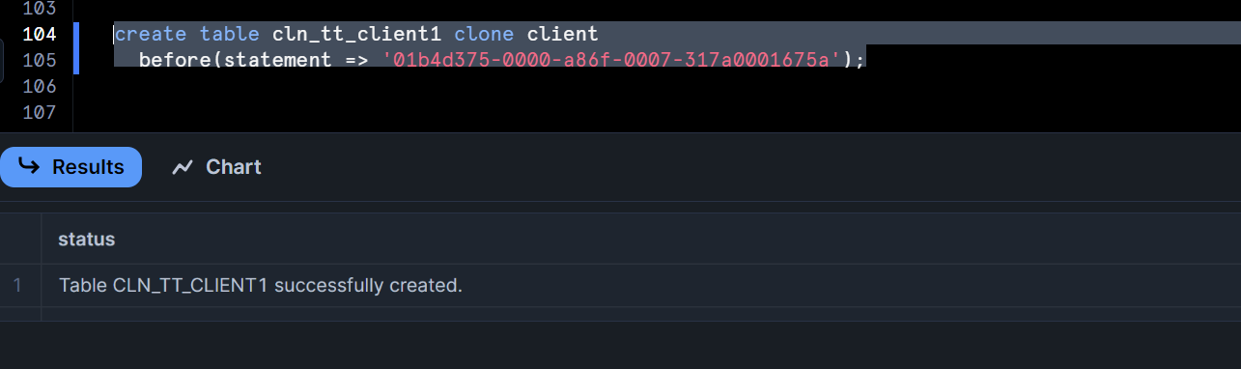

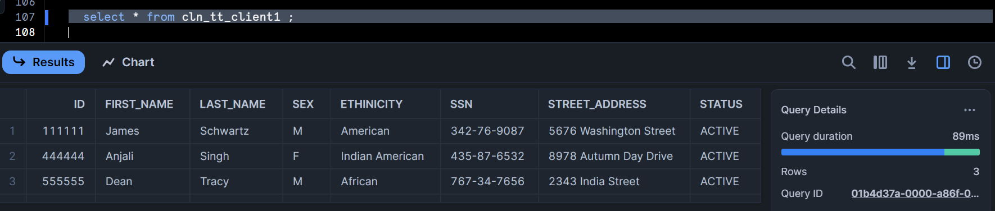

Create clone using offset

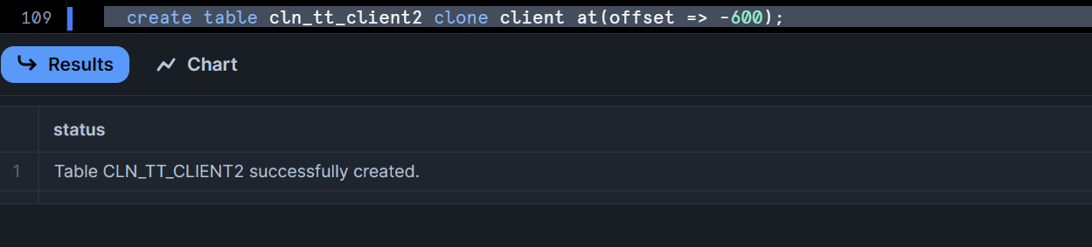

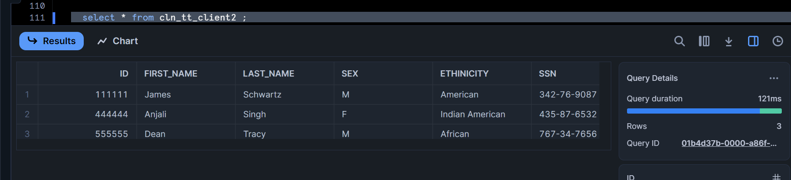

Thanks